SonarQube with Jenkins

EC2 Instance
Step 1: Create a ubuntu machine in AWS Console.
Step 2: Provide the name to your machine, and select ubuntu as the OS.
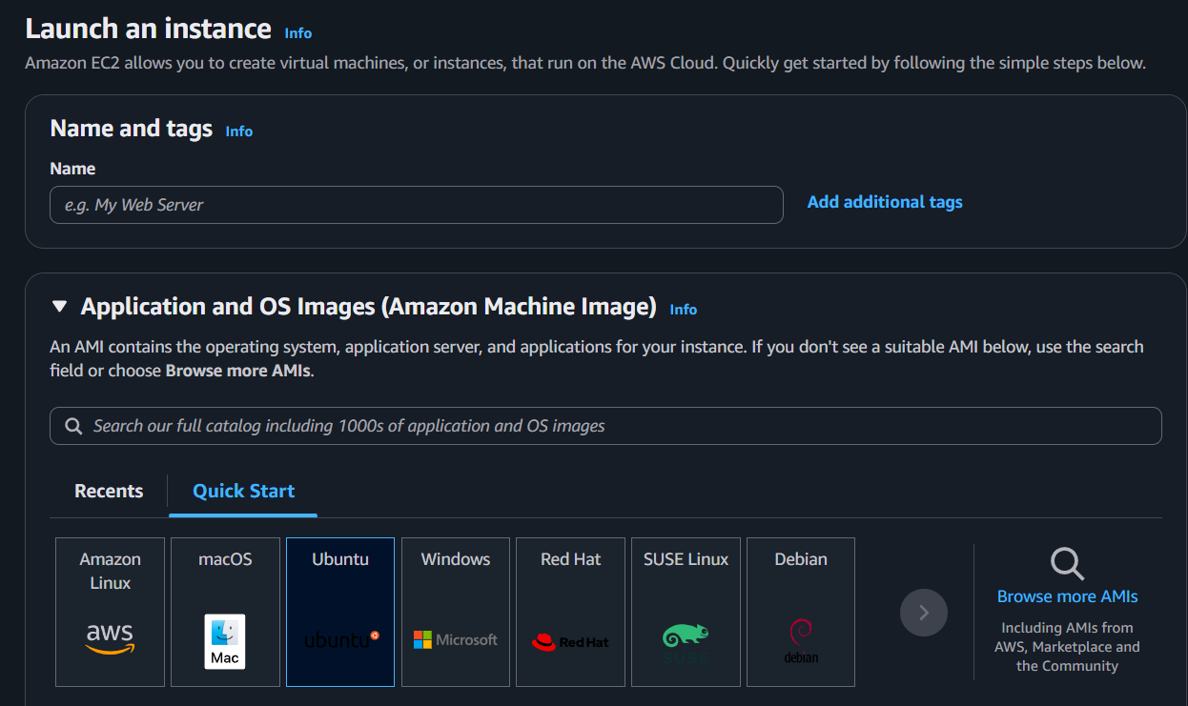

Step 3: Choose the instance type as t3.medium to run SonarQube and jenkins smoothly.
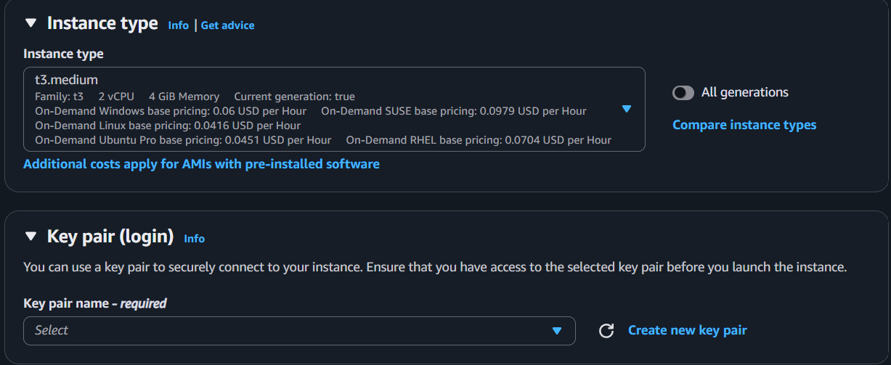

Step 4: In the Key pair (login) section, click on Create new key pair to create a key pair.


Step 5: After clicking on Create new key pair, you will see the page below figure, in that provide the any name to your key pair and click on Create key pair.

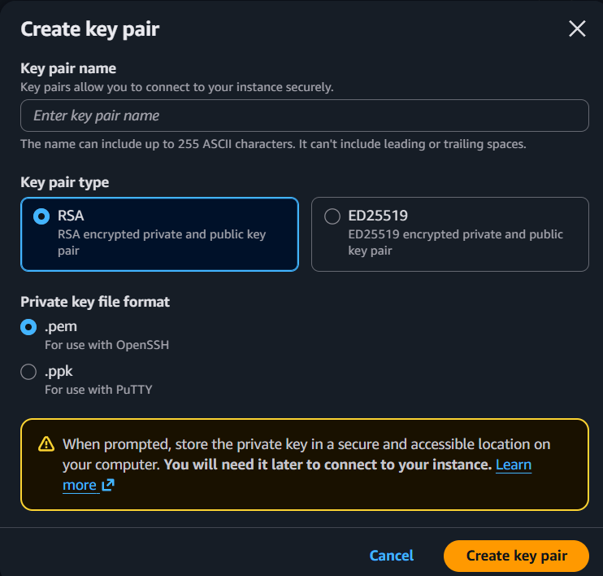

Step 6: In the Network settings section click on Edit Button.
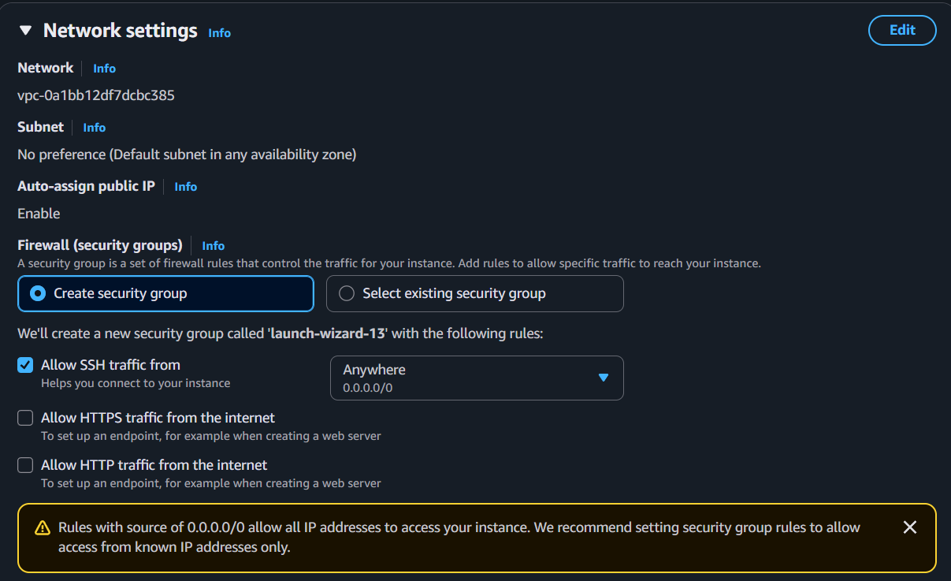

Step 7: In the edit option, when you scroll down you will see Inbound Security Group Rules, in that Type by default it would SSH, change it to All traffic from dropdown.
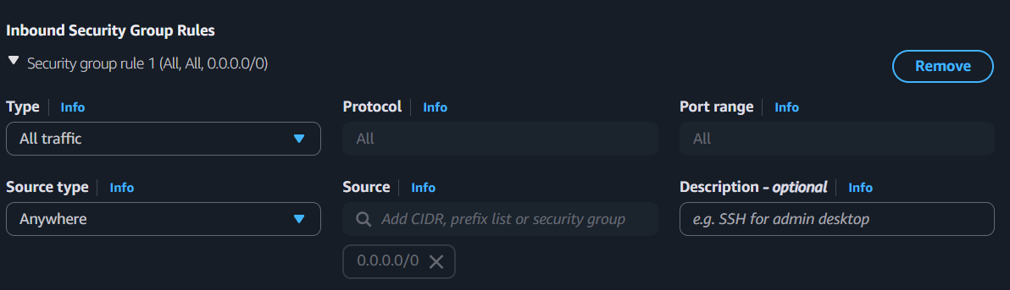

Step 8: In the Configure storage, give the storage as 20 to run SonarQube and Jenkins to run smoothly.
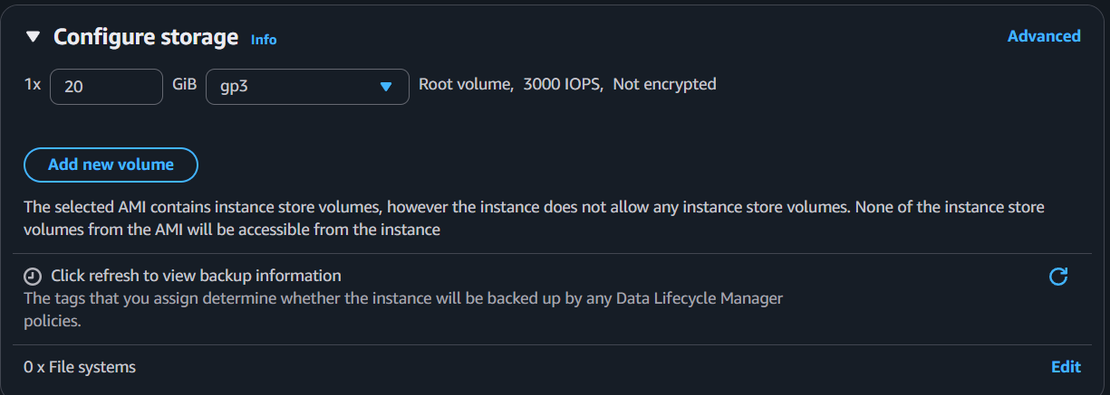

Step 9: Click on Launch Instance to launch your instance.
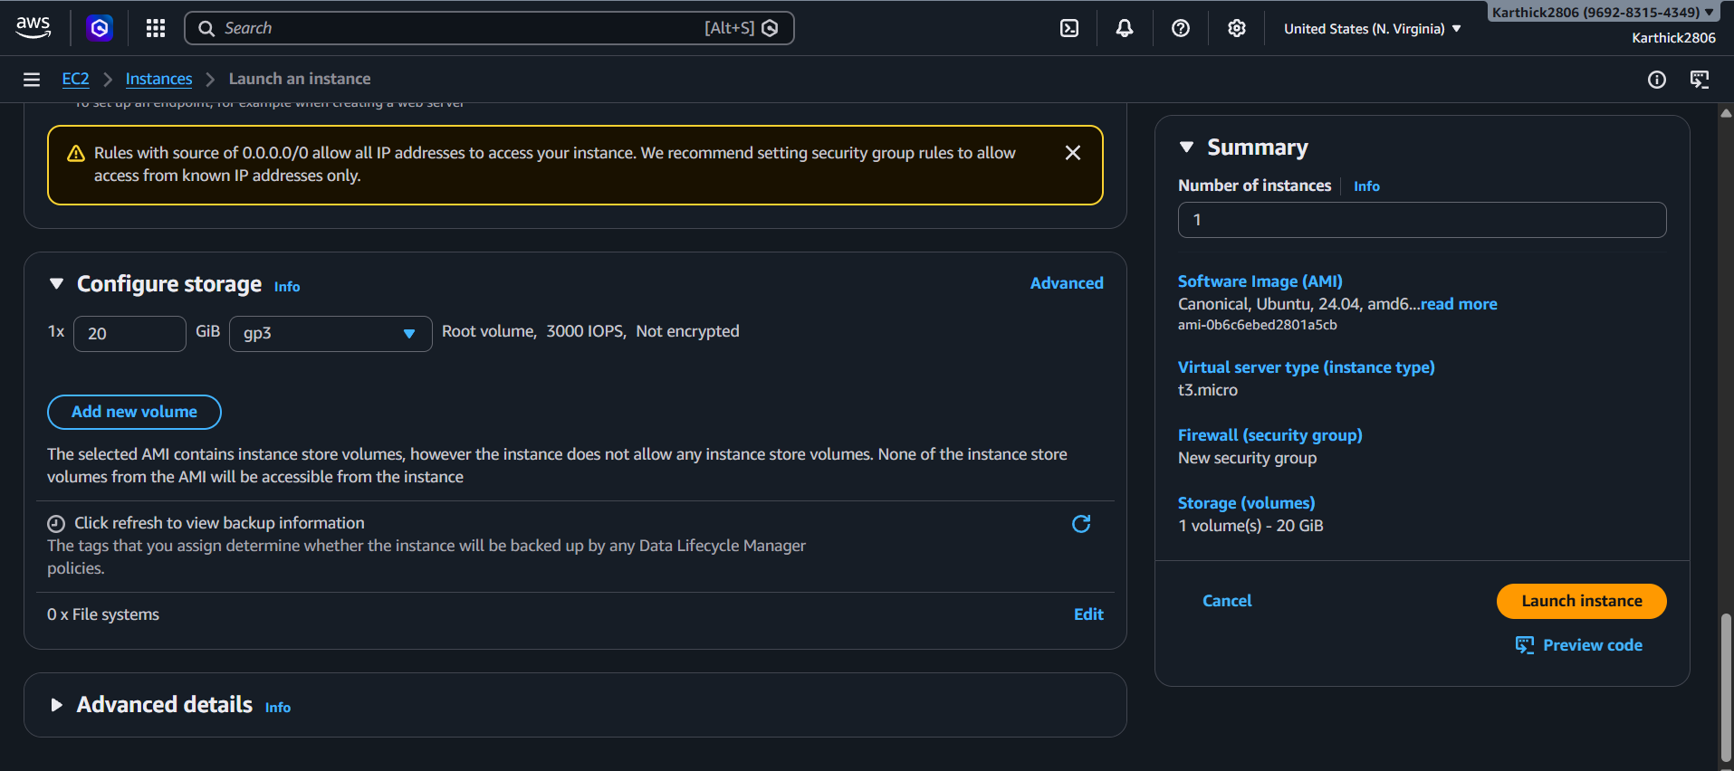

You will see the loading page like below figure.
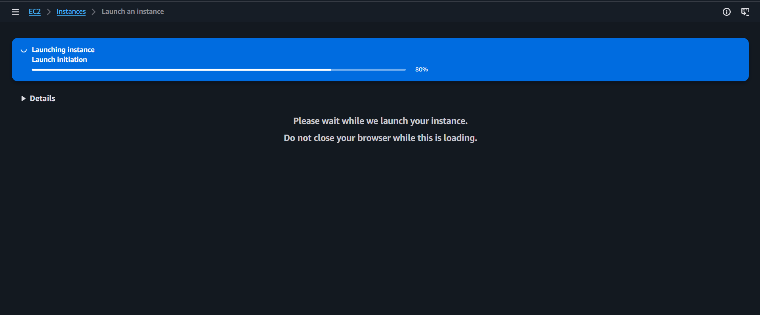

After successfully you launched your machine, it will seen like this below,
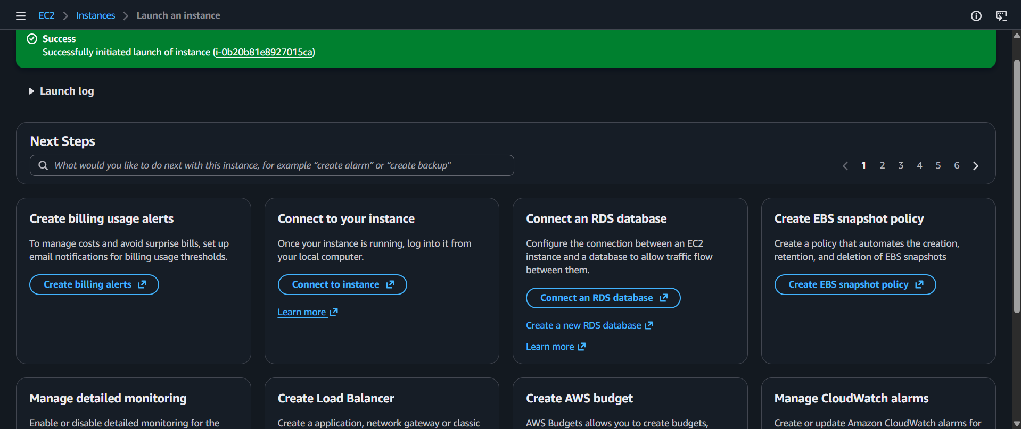

Step 10: Click on Connect to your instance to launch your ubuntu machine.


Step 11: You will see a page like below and click on connect button.
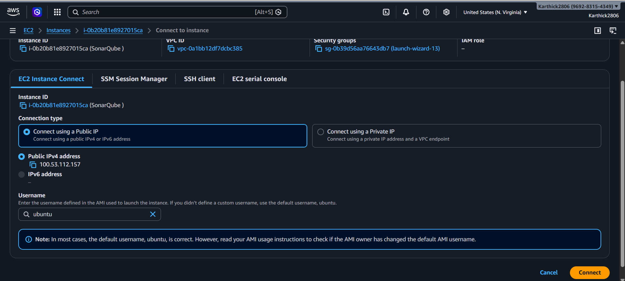

You will see a page a ubuntu terminal page like below, it means you have successfully created a ubuntu machine.
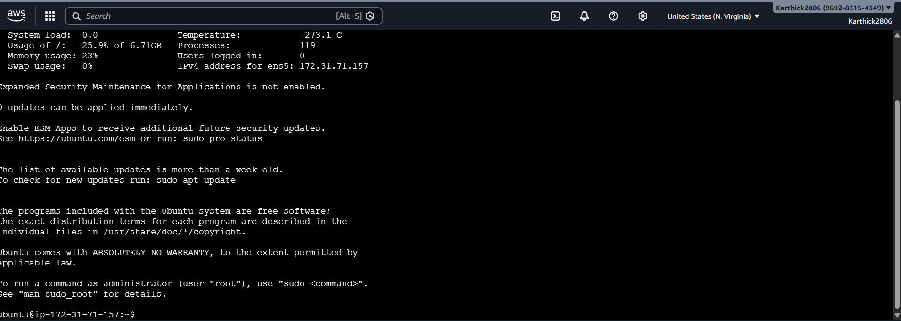

Install Sonarqube
Step 12: Refer the below document link to how to install the SonarQube in ubuntu machine.
How to install and configure SonarQube on AWS EC2 Ubuntu 22.04 and 20.04 (Full Setup)? | by DeshDeepakDhobi (DD) | Medium
Step 13: After successfully installed the SonarQube open a new tab in browser and type your machine_IP_address:9000. For example in my case my ip address is 54.234.185.73, now type the IP_address with colon 9000 like this 54.234.185.73:9000

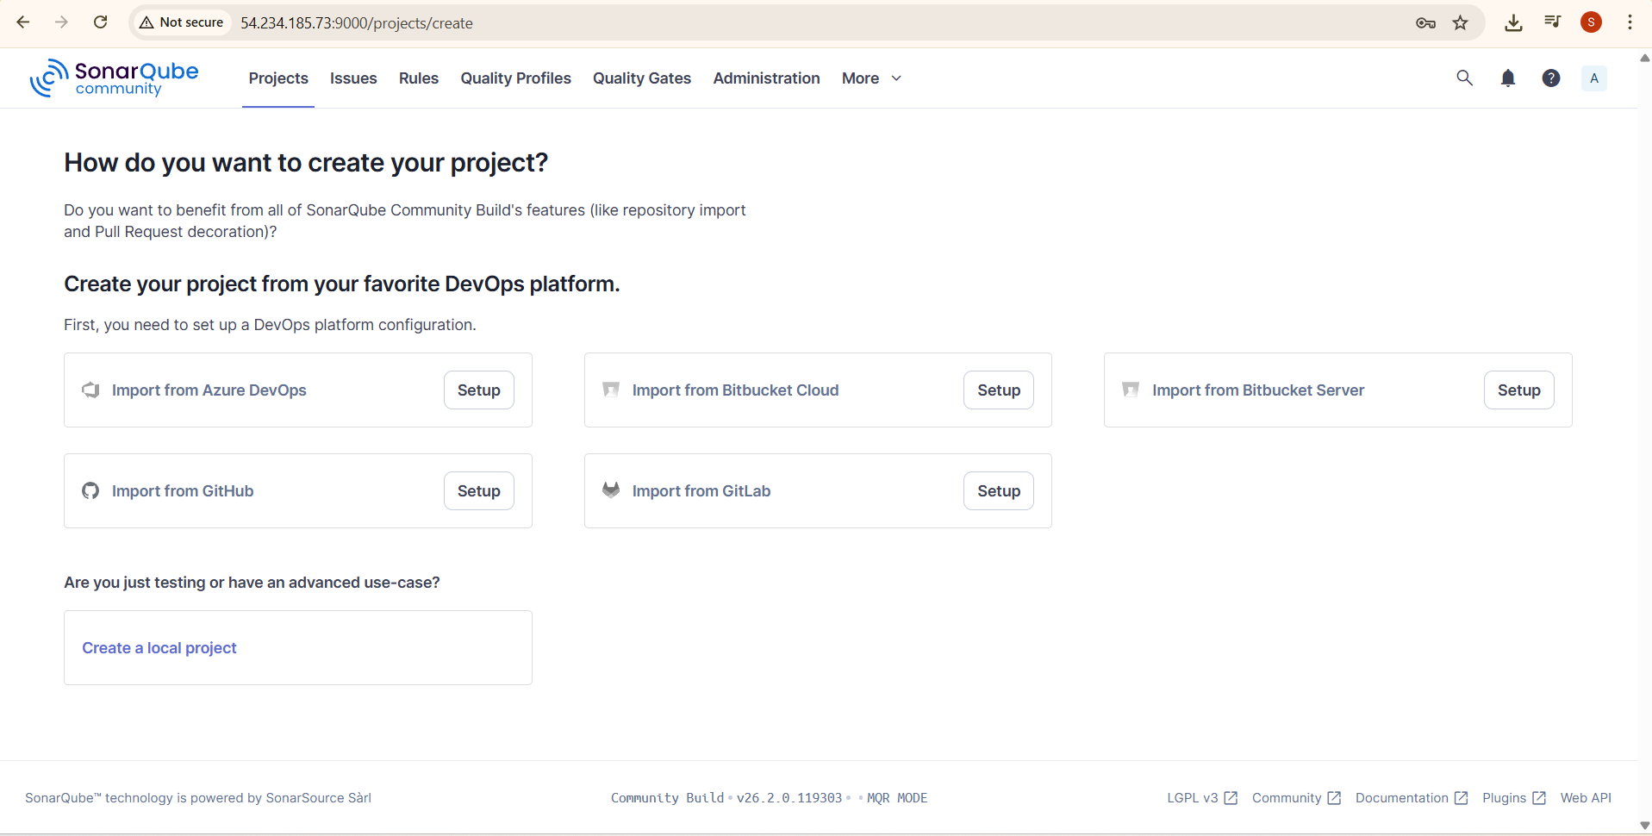

Install Jenkins
Step 14: Now install Jenkins type the following command in ubuntu machine,
wget https://raw.githubusercontent.com/akshu20791/Deployment-script/refs/heads/main/jenkins.sh
chmod 700 jenkins.sh
./jenkins.sh
Step 15: Open the new tab in browser, and paste the machine ip address:8080 to using jenkins.
Step 16: A page opens, it asks for administrator password, you will seen in the ubuntu machine as shown below.
In your case, the password will be different.
Step 17: Finish your Setup process, then you are successfully installed jenkins. You will see a like this as shown below.
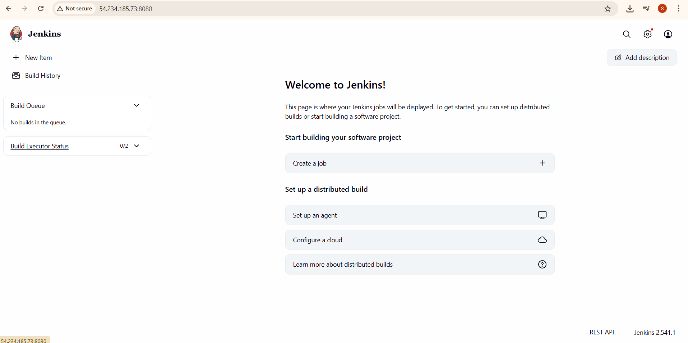

GENERATE SECURITY key in Sonarque

Step 18: Now the tab where you opened your SonarQube and select Administration
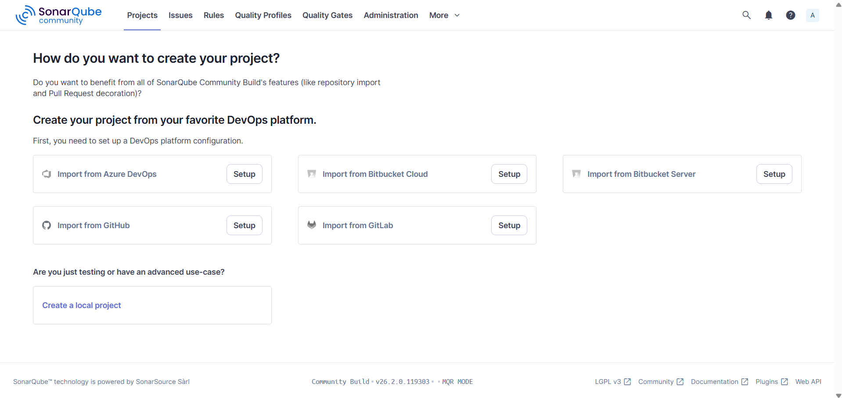

Step 19: Then click on security 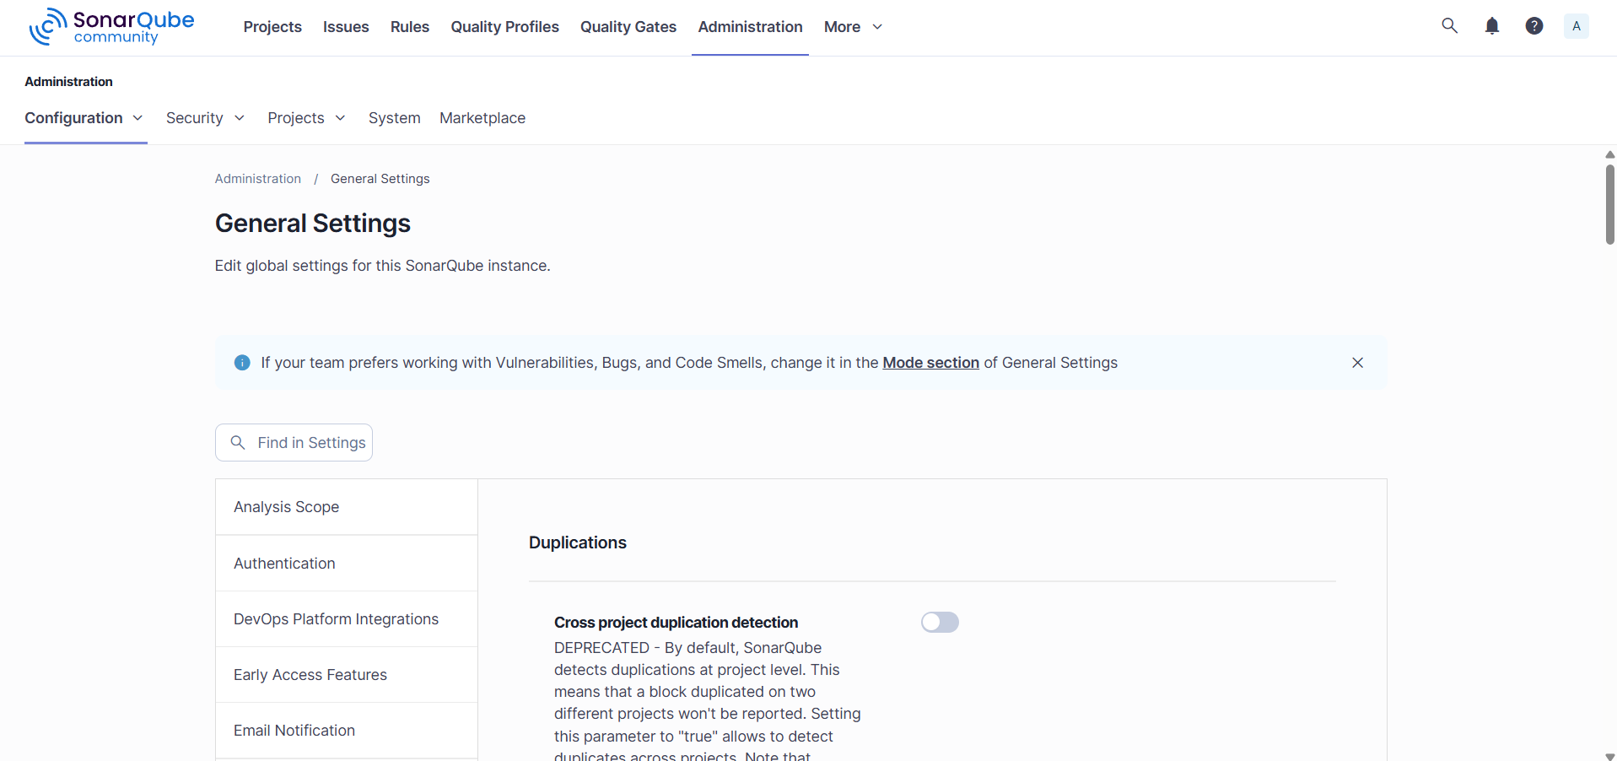

Step 20: Click on Users
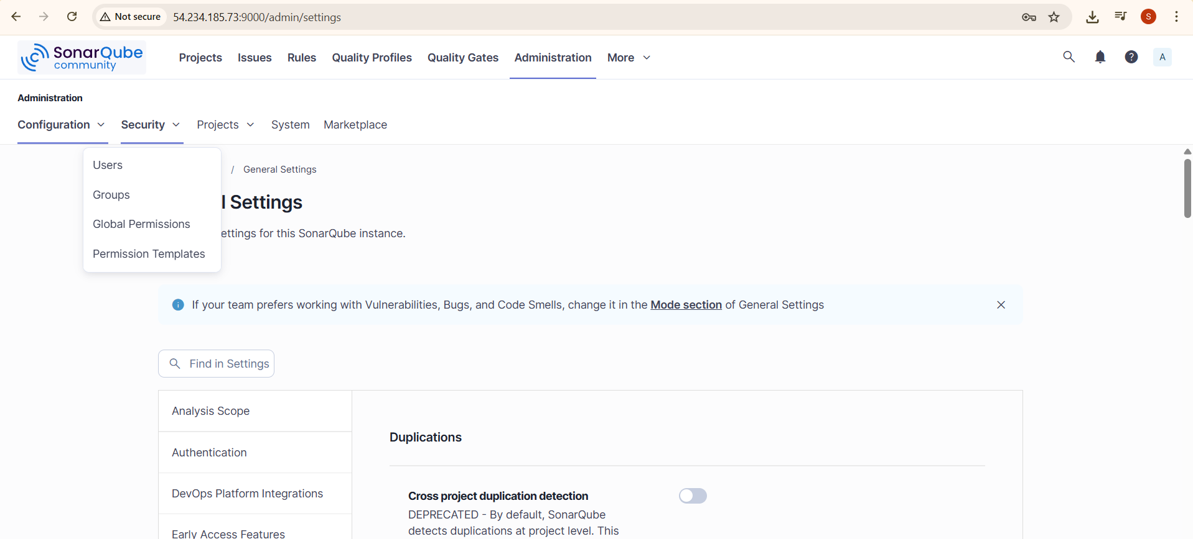

Step 21: A user page will be open, in that click on three dots in Tokens column.
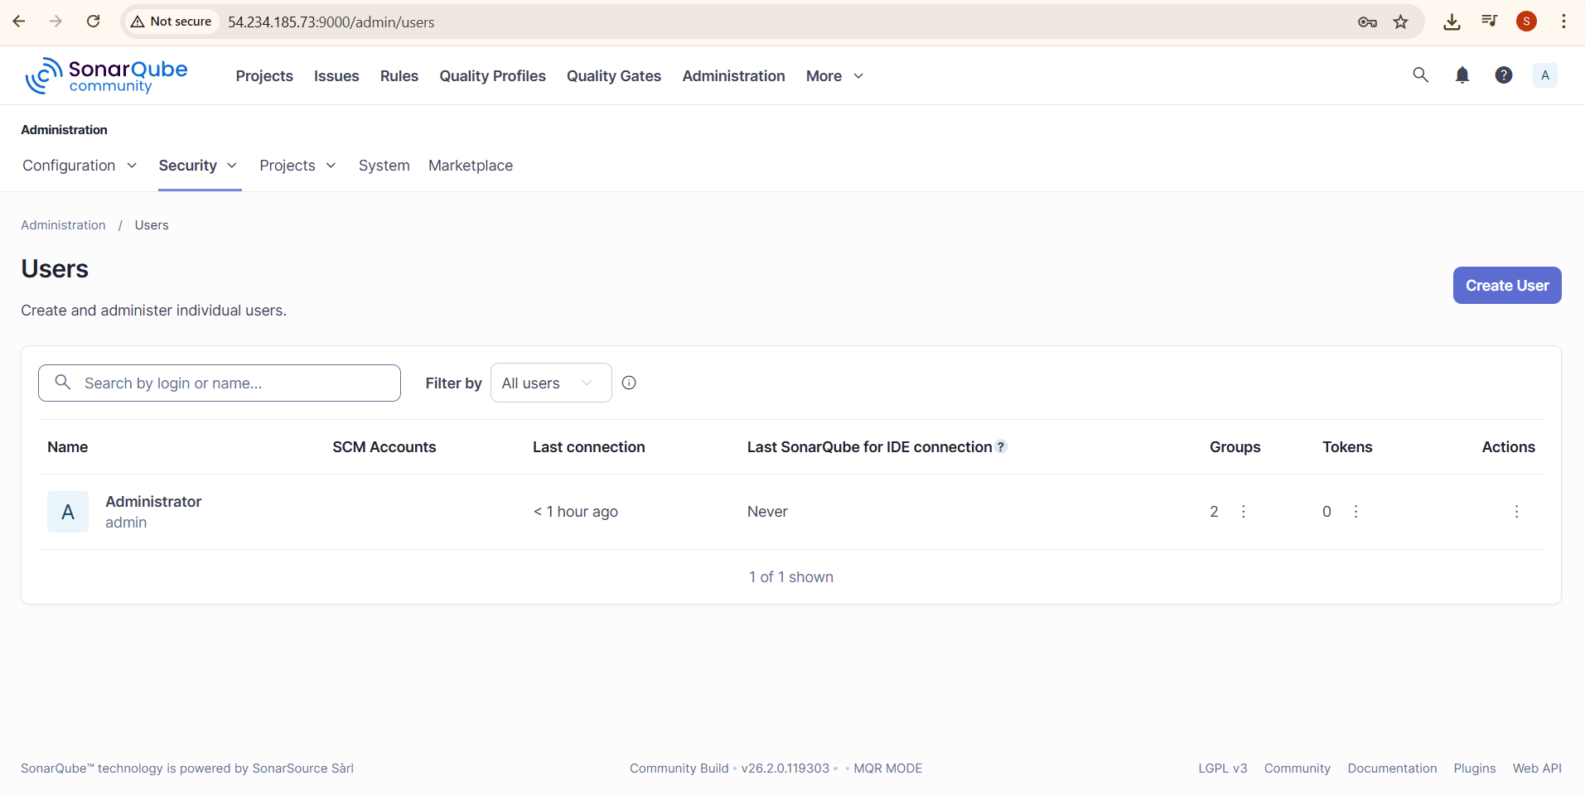

Step 22: Enter the token name and click on the generate button to generate a token. Copy the token and save it on any notepad.
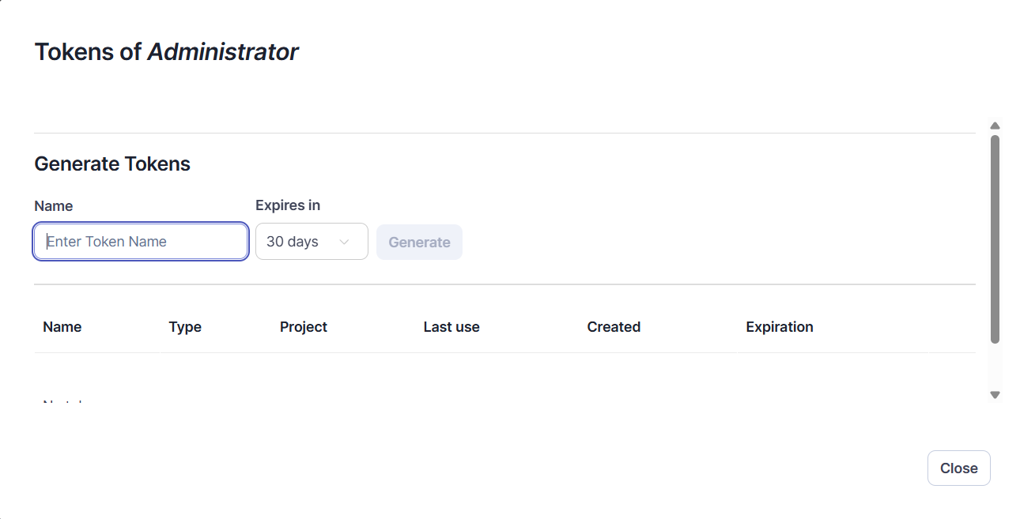
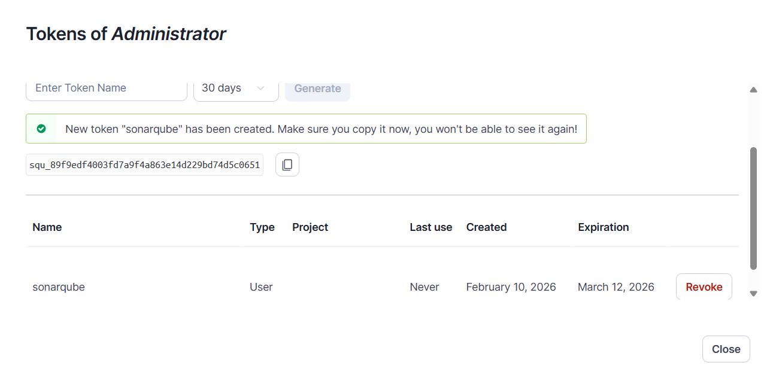
You will be able see the generated token as shown in above figure.

Install Sonarque plugin in Jenkins
Step 23: Open Jenkins, and click on manage jenkins as shown below Figure.
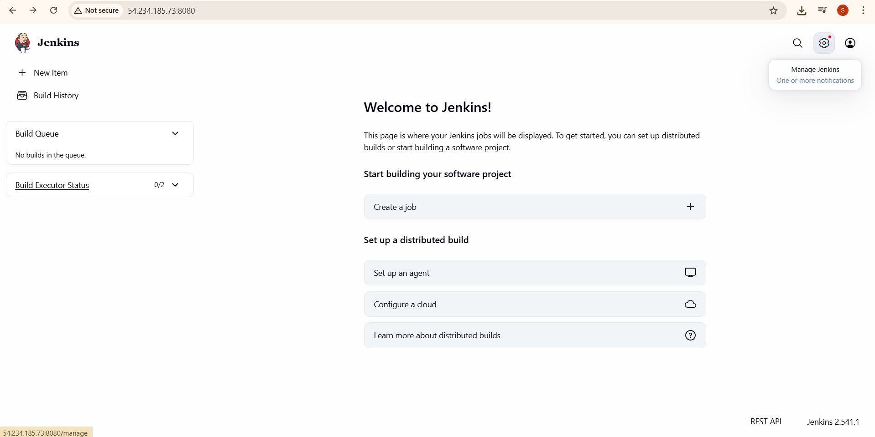
Step 24: Select plugins options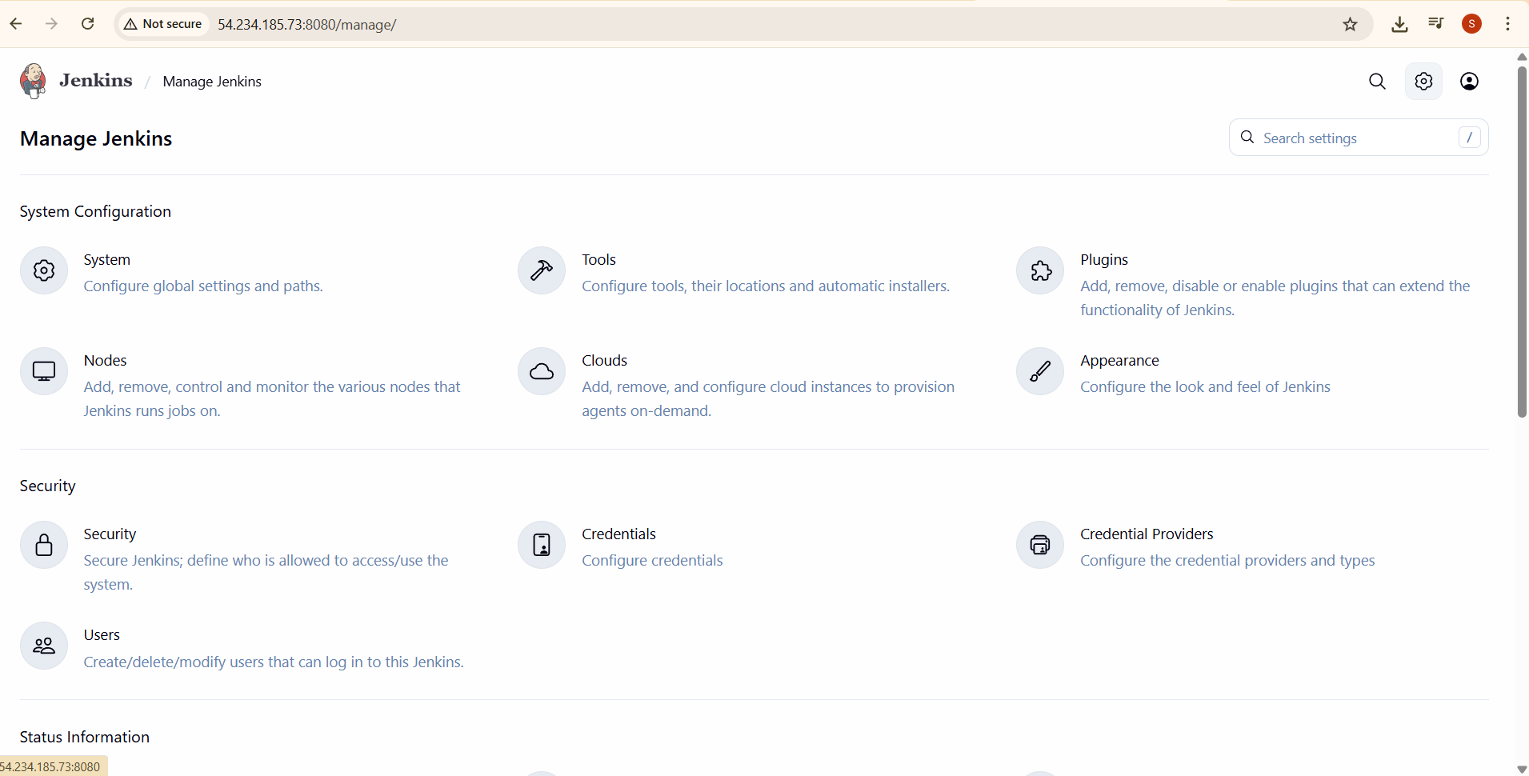

Step 25: Select available plugins.
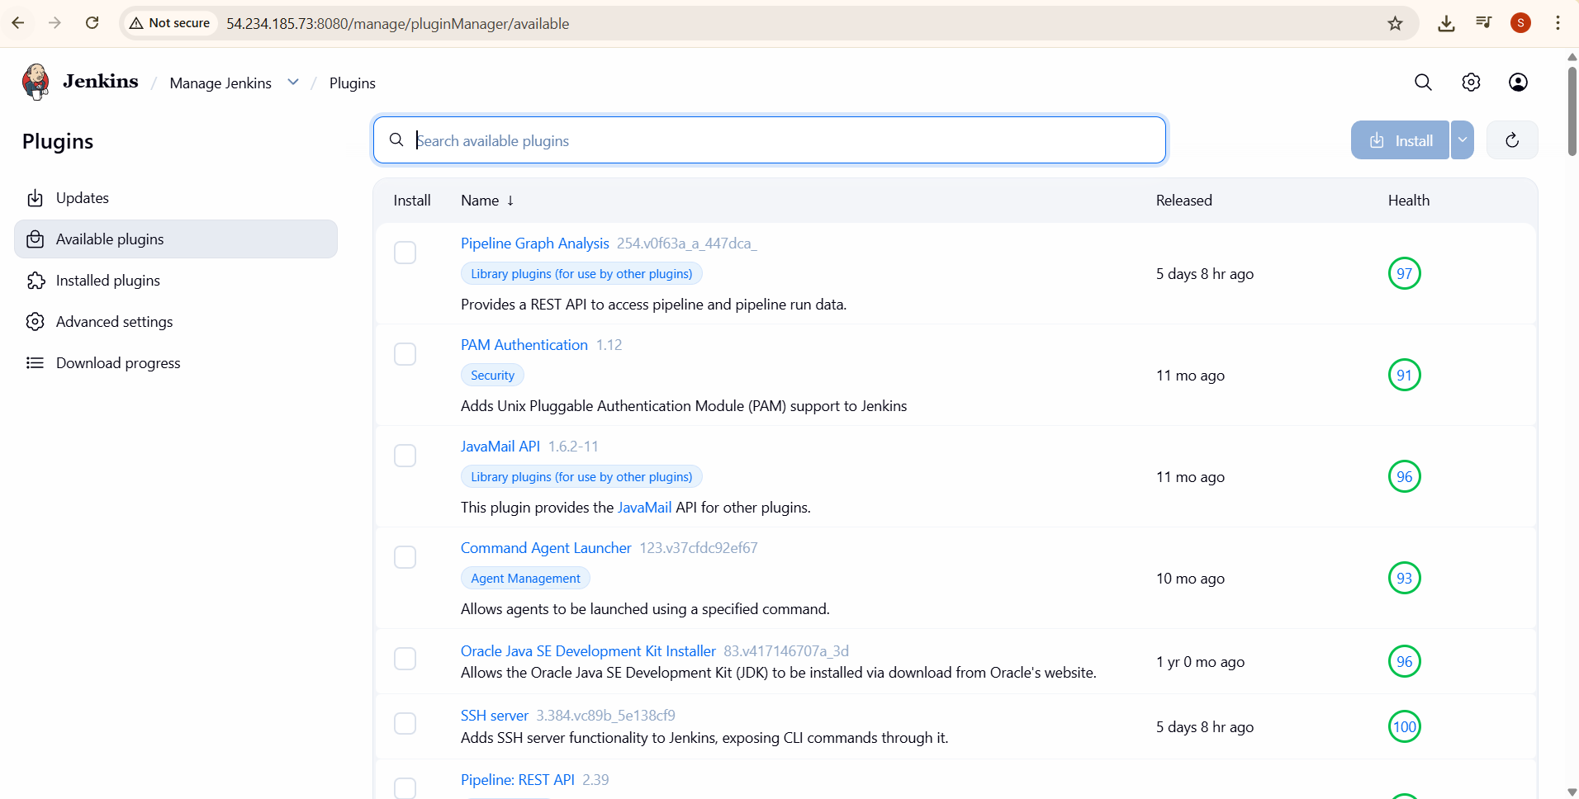

Step 26: In the Search bar type SonarQube Scanner Click on install button.
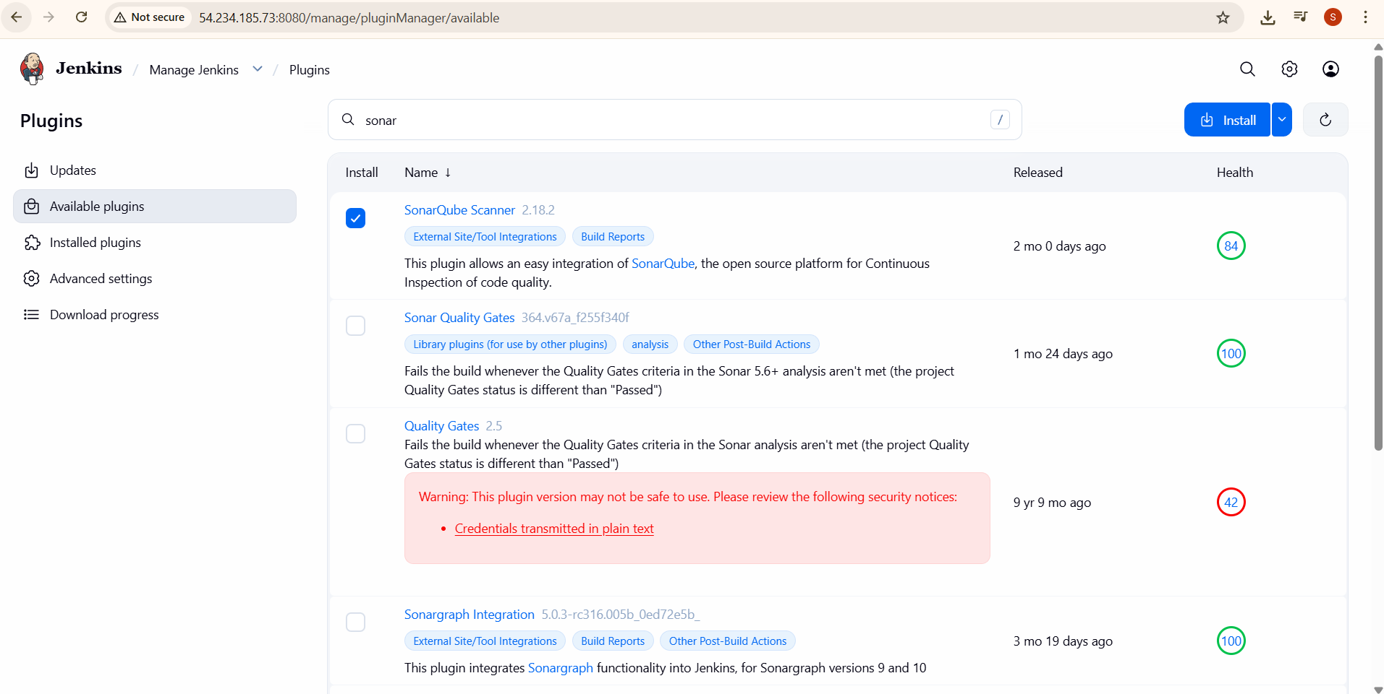

Sonarque security token to be provided jenkins
Step 27: Click on Manage Jenkins and select Credentials
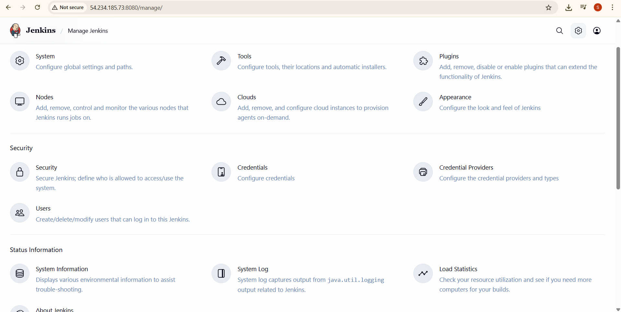

Step 28: Click on global

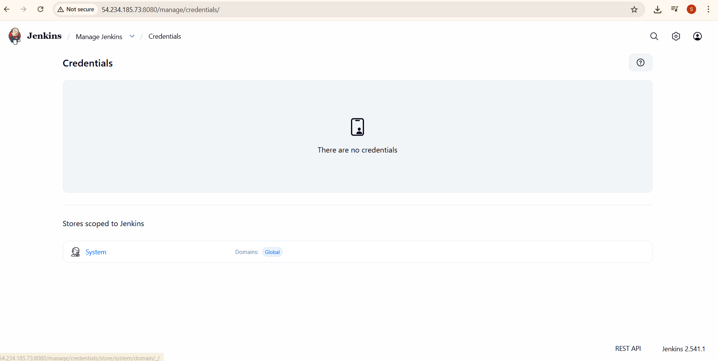

Step 29: Click on adding some credentials?
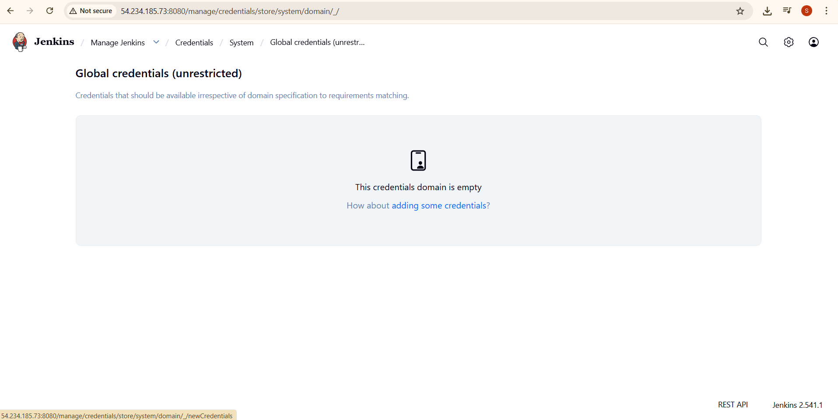

Step 30: Select the kind as Secret text from the drop-down. Paste the token that you had earlier copied from the SonarQube server into the Secret field and type any name for ID field and click on create button.
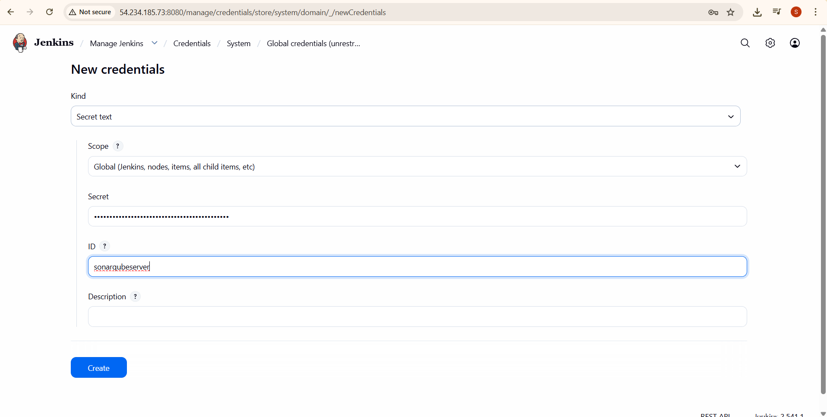

You will see the credentials added in the Global credentials page.
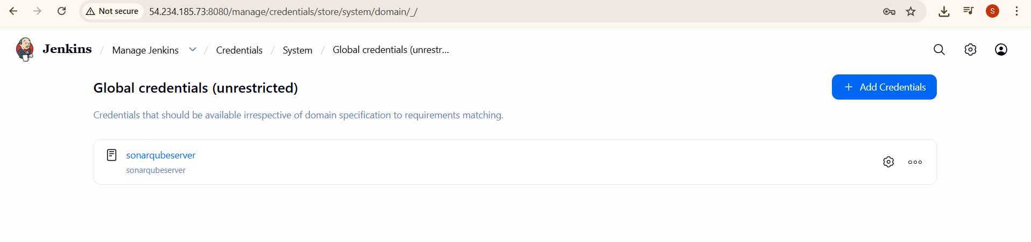

Specify the URL of sonarque
Step 31: Again come back to Manage Jenkins and click on System.
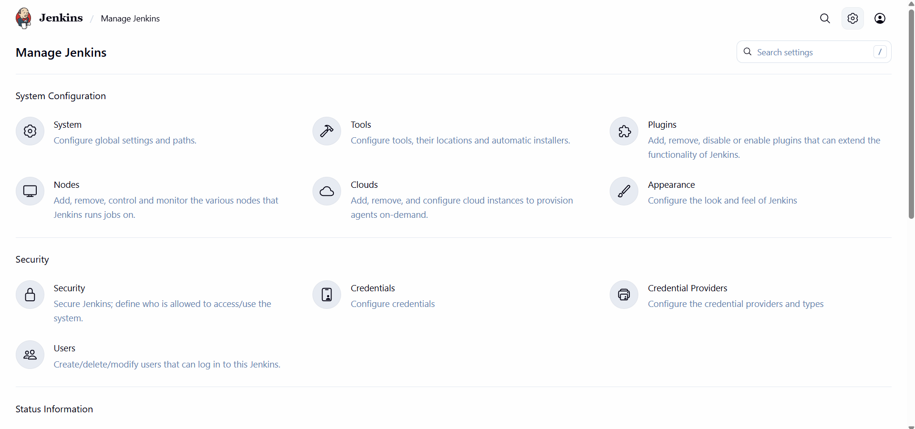
Step 32: System page will be open in that scroll down and you will find SonarQube servers section as shown below.
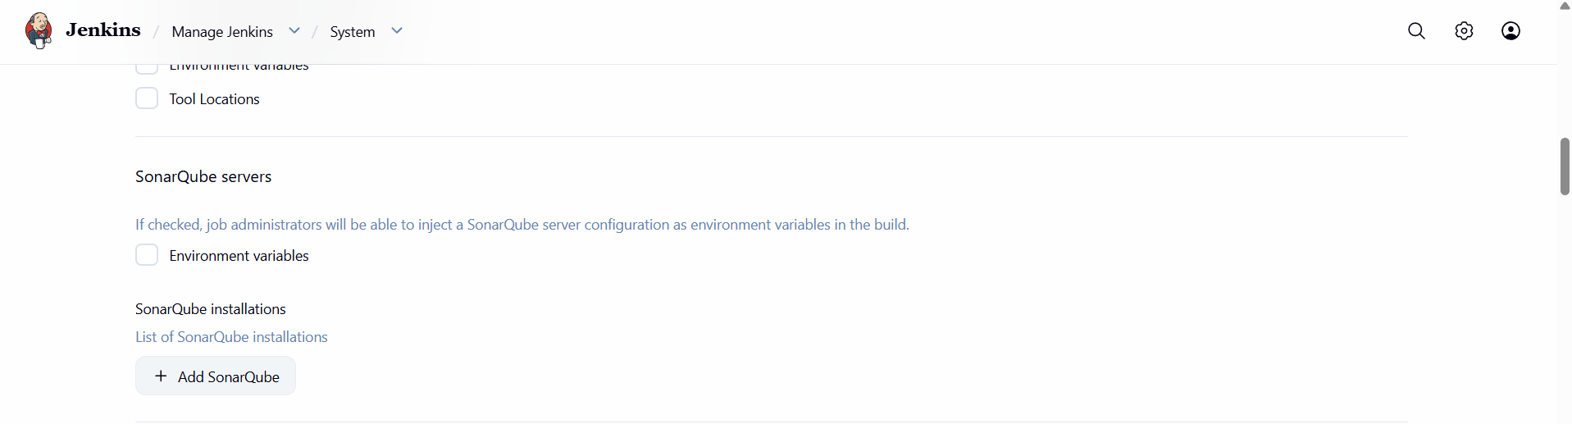

Step 33: Click on the checkbox Environment variables and click on Add Sonar Qube.


Step 34: Provide a name and Server URL as http://localhost:9000. Select the authentication token from the list and click on apply and save. You have successfully created a SonarQube server now back page of jenkins.
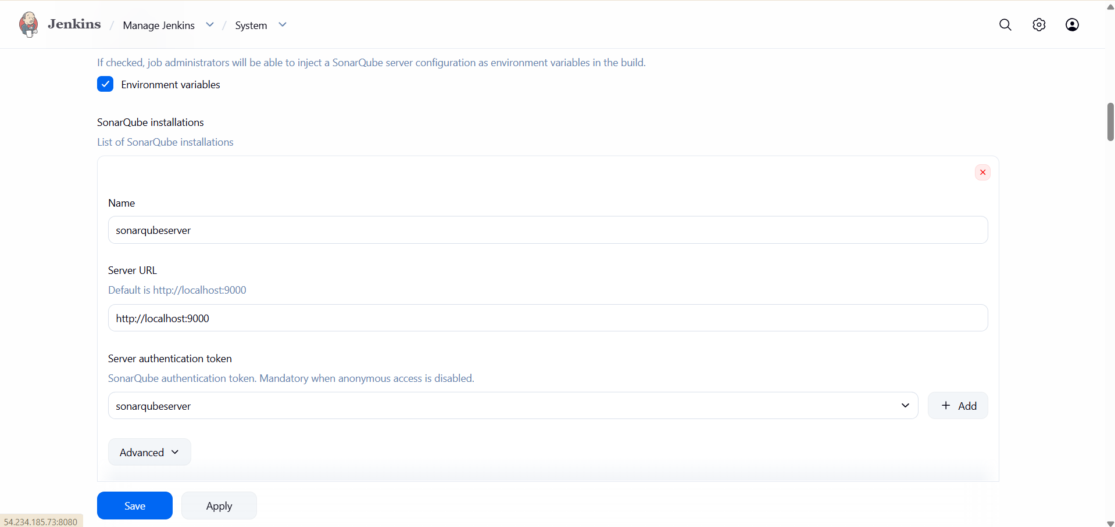

CREATE PIPELINE JOB
Step 35: Click on Create a job
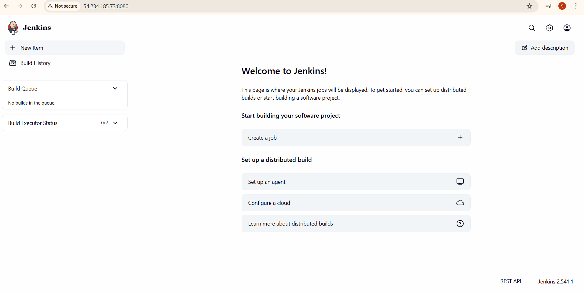

Step 36: Provide a name to your job and select Pipeline as item type and click Ok button.
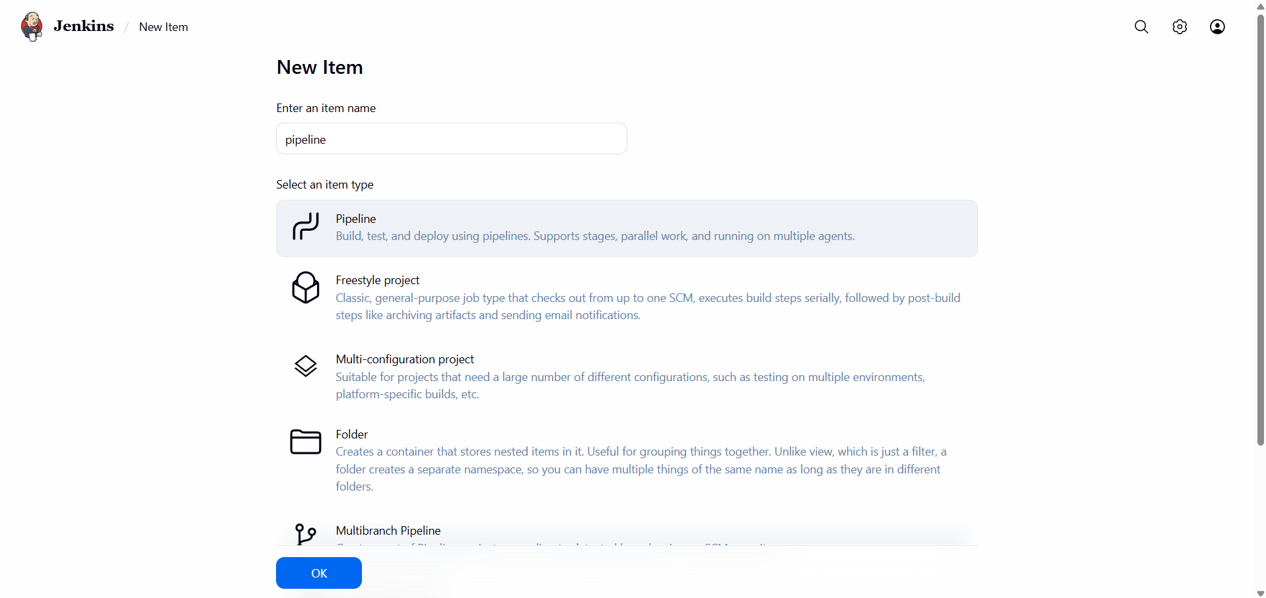

Step 37: You will see a page like below figure in that click on pipeline.
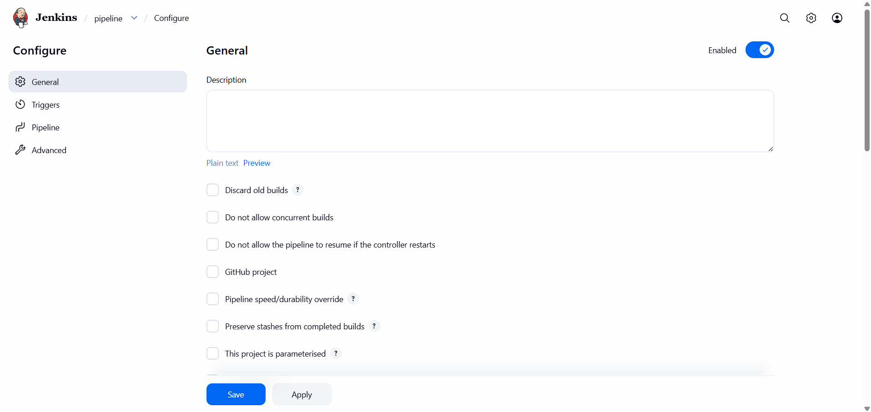

Step 38: You will see a like below Figure.
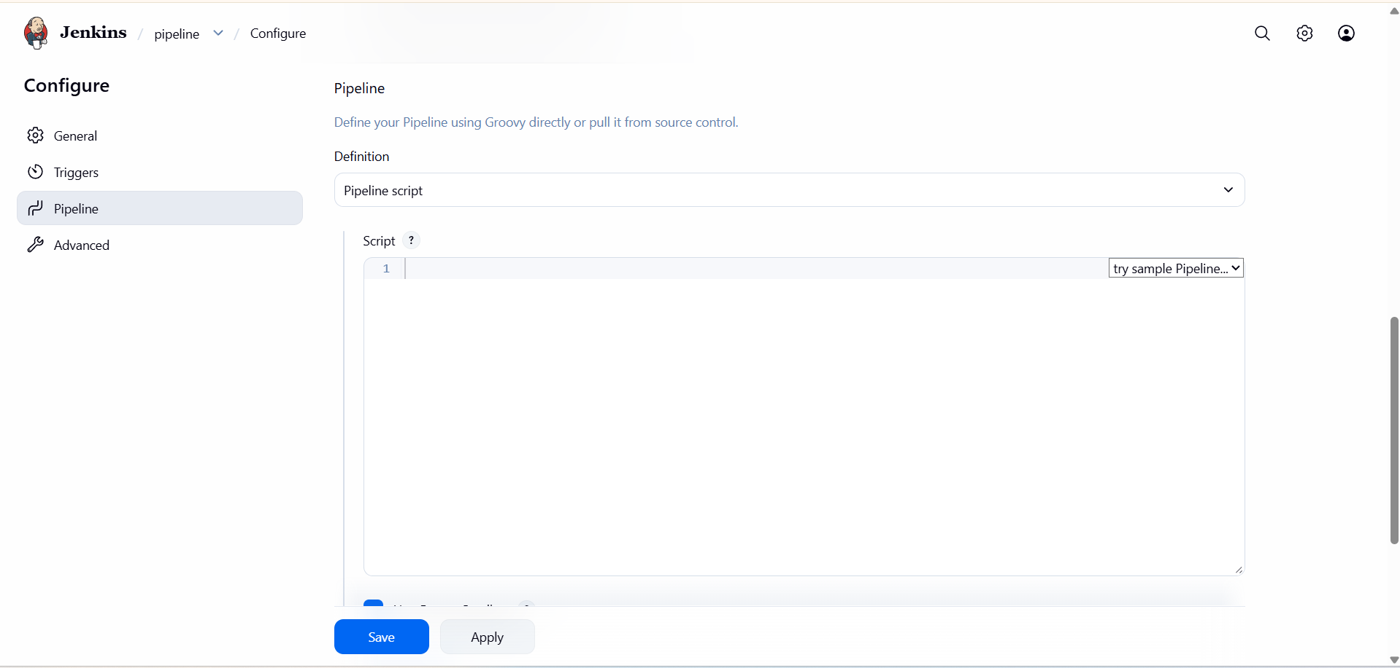

Step 39: In the script field type the following script in editor to build the job.


Pipeline Code:
pipeline{
agent any
stages{
stage('github validation new'){
steps{
git url: 'https://github.com/akshu20791/addressbook-cicd-project'
}
}
stage('compiling the code'){
steps{
sh 'mvn compile'
}
}
stage('testing the code'){
steps{
sh 'mvn test'
}
}
stage('qa of the code'){
steps{
withSonarQubeEnv('Sonarqubeserver') {
sh 'mvn clean compile org.sonarsource.scanner.maven:sonar-maven-plugin:3.9.1.2184:sonar'
}
}
}
stage('package'){
steps{
sh 'mvn package'
}
}
}
}

Step 40: After the typing the following script, click on apply and save button.
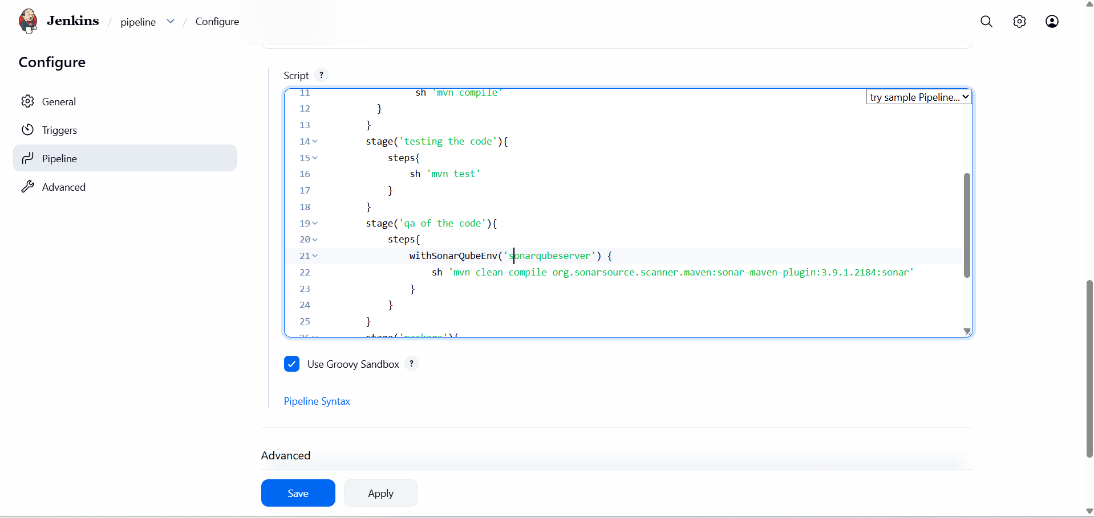

BUILD the Job
Step 41: After clicking on save button you will see a page like below figure, in that click on build now.

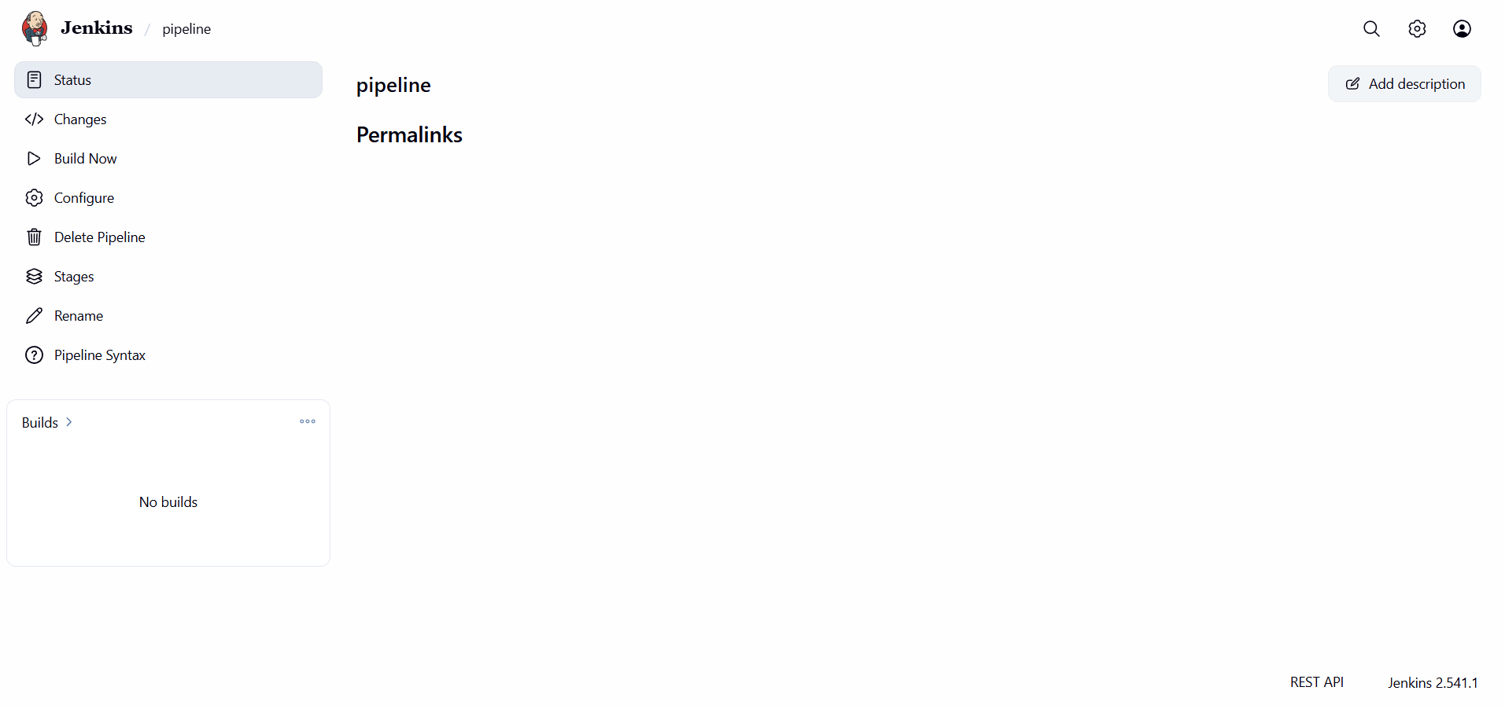
You will see a success page like below figure, it means you have successfully build the project.
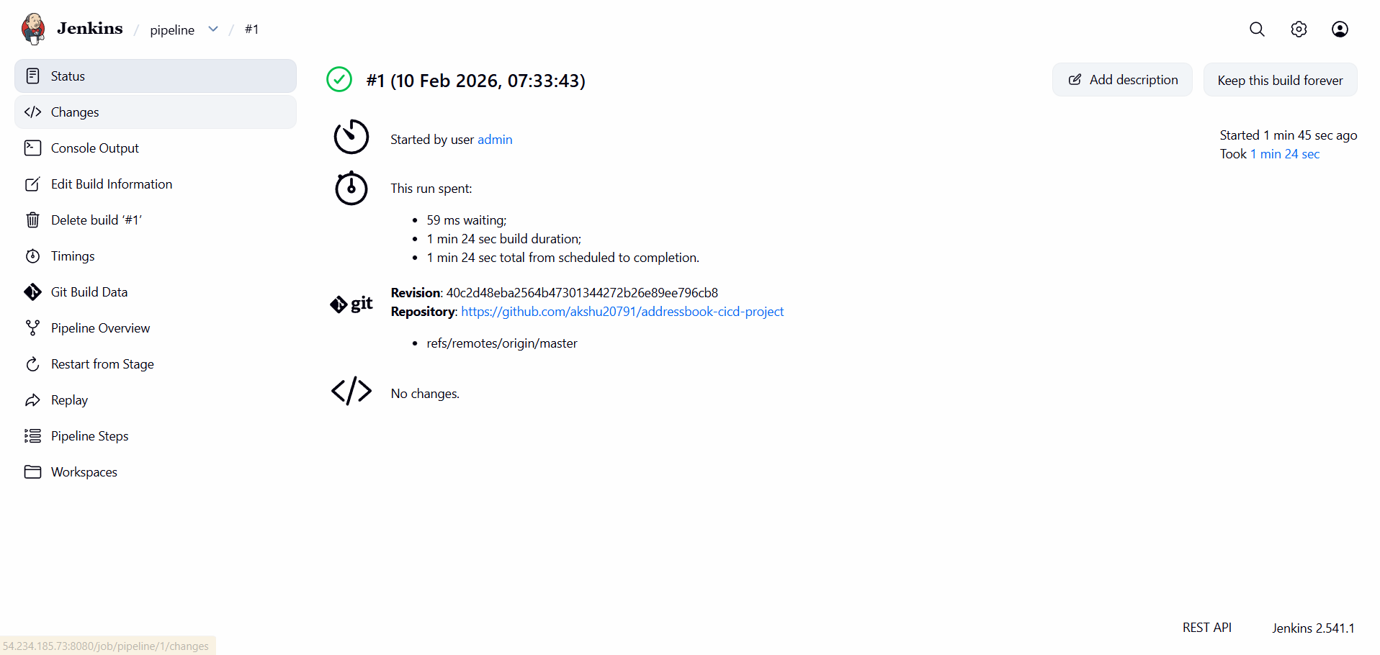

VIEW the Sonarqube reports
Open a SonarQube tab will see like below, the project is successfully passed.
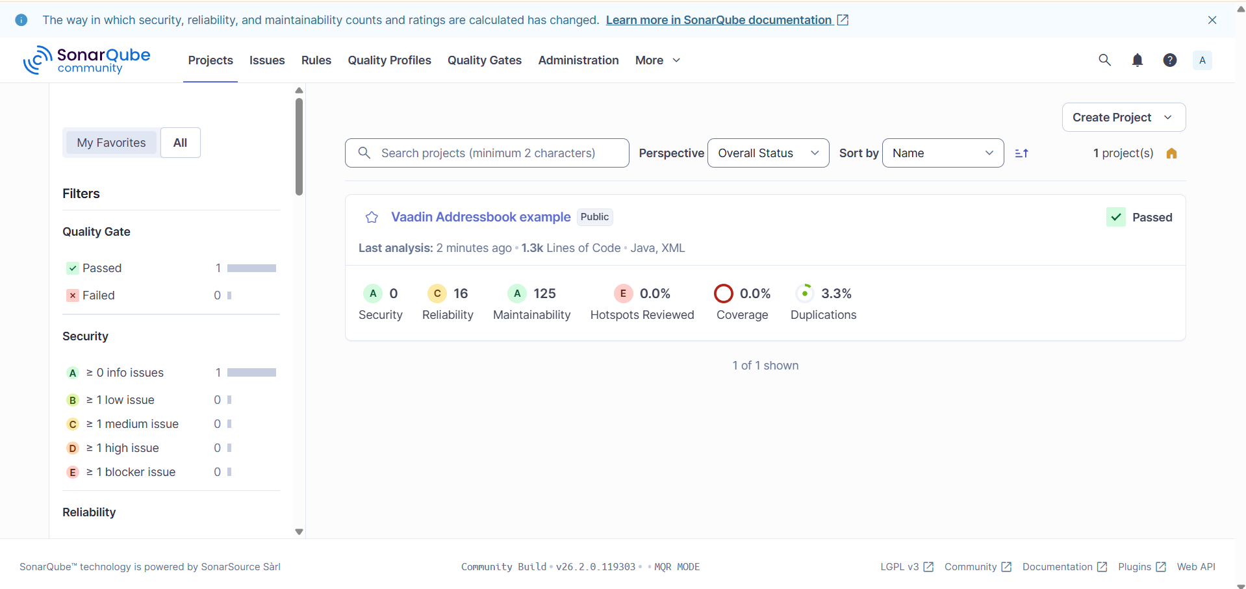

If you click on the Vaadin Addressbook example you will see below figure.
